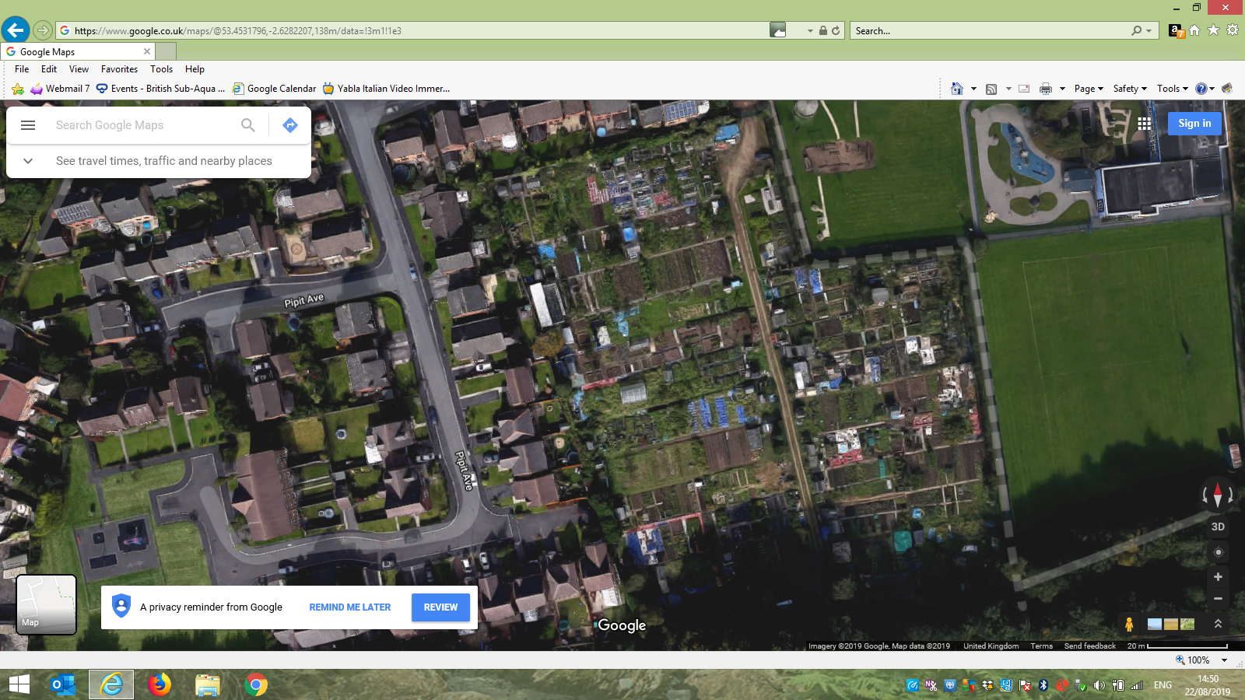**MESNES PARK ALLOTMENT SITE**

**Can you spot your plot?**